**Template Community Engagement Plan for Australian Councils**

Template prepared by the Australian Centre of Excellence for Local Government

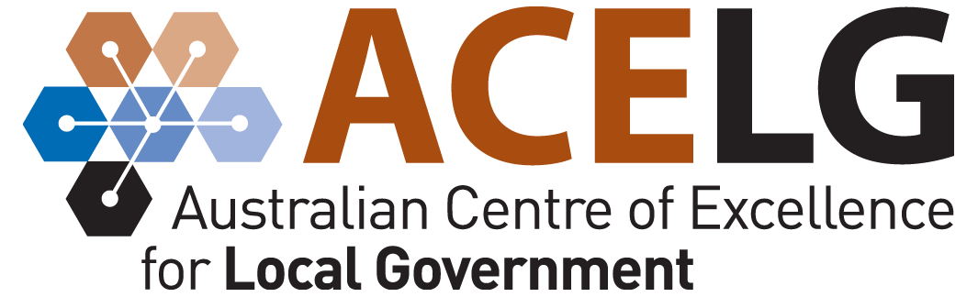

[**www.acelg.org.au**](http://www.acelg.org.au)

Ph: 02 9514 3855

E: [acelg@acelg.org.au](mailto:acelg@acelg.org.au)

Insert Council copyright etc here

Introduction 1

The guiding principles of council’s community planning and service delivery 1

Stakeholders in the [*name of council*] area 1

Outcomes of community engagement 1

Outcomes for our communities 2

Outcomes for the council 2

Community engagement processes 2

Preparation for engagement activities 2

Publicity and community information 3

Post-engagement actions 3

# Introduction

This plan identifies localities, population groups and organisations within the

*[name of council]* area that are targeted in community engagement processes to enable the development of the council’s community plan.

It also describes the approaches and methodologies that are used for engagement, and identifies the principles that guide these processes.

# The guiding principles of council’s community planning and service delivery

Community planning and service delivery in the *[name of council]* area is guided by social justice principles as follows:

**Equity** – there is fairness in the prioritising and allocation of resources. Care is taken to involve and protect the interests of people in vulnerable circumstances.

**Rights** – peoples’ rights are recognised and promoted with opportunities provided for people from diverse linguistic, cultural and religious backgrounds to participate in local community activities.

**Access** – people have fair access to resources and services essential to meet their basic needs and to improve their quality of life.

**Participation** – people have opportunities for genuine participation and consultation about decisions affecting their lives.

# Stakeholders in the [*name of council*] area

Stakeholders to target for inclusion in community engagement activities may include:

* towns and villages, including []
* localities, including [] and surrounding areas
* the local rural population
* business owners
* government agencies with responsibilities in the council area
* non-government and community organisations
* children and young people
* elderly people
* *[other groups as appropriate].*

# Outcomes of community engagement

Engagement processes associated with the development of the community plan will deliver the following community (external) and organisational (internal) outcomes:

# Outcomes for our communities

* Identify community priorities and expectations for the future of the local area.
* Build positive relationships between council and local communities.
* Foster a greater community understanding of the roles and responsibilities of council.
* Build community ownership of, and connectedness with, the council’s community planning process.
* Provide opportunities for all community members to participate in the development of the vision and long-term goals of the local area.
* Foster common understandings and productive relationships between other service delivery agencies in the public and private sectors.
* Determine community expectations regarding council’s service levels.

# Outcomes for the council

* Develop clear strategic objectives for council.
* Build council capacities in working with local community groups.
* Develop a cross-council understanding of, and familiarity with, local communities.
* Create opportunities to examine how staff roles and activities relate to the broader community.
* Facilitate greater organisational understanding of, and participation in, the community planning process.
* Provide councillors with opportunities for frontline involvement in community engagement activities.
* Build councillor awareness of the importance of their role in community leadership.

# Community engagement processes

*[Provide a detailed outline of community engagement processes to be conducted for the development of the community plan.]*

# Preparation for engagement activities

The following items will require attention in planning and preparing for engagement activities:

* venue(s) and accessibility
* timing of engagement activities
* catering
* audio-visual requirements
* stationery requirements
* tables and seating
* heating / cooling requirements
* access to kitchen / toilets
* staff roles and responsibilities.

# Publicity and community information

To enable the community planning process to develop a high profile across the local area, it will be important to give the process a distinct identity whilst maintaining strong links with council.

This identity may be developed through the creation of a specific name and logo for the project, and/or through a range of publicity and community information activities, including:

* distribution of a community briefing paper about the ILTP process
* local radio interviews, e.g. with the mayor and/or CEO
* local newspaper content, e.g. articles, press releases, council advertisements
* community newsletters
* posters and flyers to publicise the development of the community plan and to give planned community engagement processes a high profile.

# Post-engagement actions

**Keep them informed –** *Engagement activities are often surrounded by a great deal of energy and enthusiasm, both in council and throughout local communities. However, once this energy has subsided, it is very important to ensure that communities are kept informed of the progress in developing the community plan and any future opportunities for their involvement.*

**Access to data –** *To ensure that all processes surrounding the development of the community plan are transparent and accountable, it is important to make all raw data gathered during engagement activities publicly available in hard copy and/or on the council’s website. It is important to ensure that individual participants in the engagement process are not identified in the data.*

**Observe the timetable –** *Once the timetable for development of the community plan is set and publicised, it is important to stick to it. Communities will regard the various stages of engagement as milestones in the overall process, and it is most important to maintain community trust and support by meeting their expectations in this regard.*

**Evaluation –** *Following each round of community engagement, it is important for the planning team to evaluate the community engagement process utilised. An evaluation of these processes will enable staff to pinpoint the strengths and weaknesses of their approach to community engagement, and will foster a ‘continuous improvement’ approach to planning and managing community engagement*.

INSERT COUNCIL LOGO FOR BACK PAGE HERE