Template Community Plan for Australian Councils

Template prepared by the Australian Centre of Excellence for Local Government

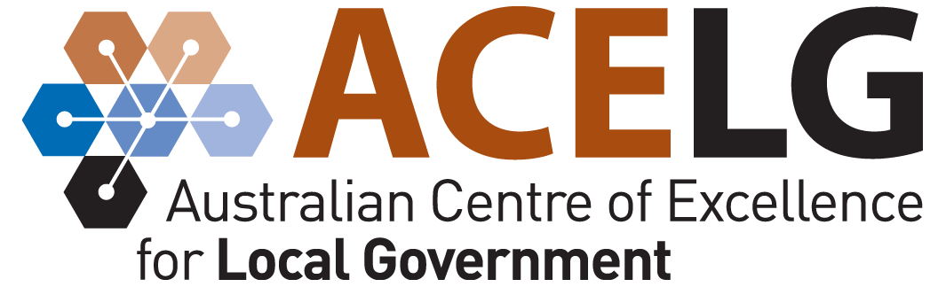

www.acelg.org.au
Ph: 02 9514 3855
E: acelg@acelg.org.au

Insert Council copyright etc. here
Focus area 1: Natural Environment 1
Focus area 2: Local Economy 4
Focus Area 3. Community and Culture 7
Focus Area 4. Rural and Urban Development 10
Focus Area 5. Infrastructure and Services 13
Focus Area 6. Local Governance and Finance 16

Focus area 1: Natural Environment

Community perceptions of [name of council] area

What we value

Priorities for our future

Our goal for our natural environment
[Goal statement for the natural environment]

Strategies to achieve this goal

Indicators of progress towards this goal

Focus area 2: Local Economy

Community perceptions of [name of council] area

What we value

Priorities for our future

Our goal for our local economy
[Goal statement for the natural environment]

Strategies to achieve this goal

Indicators of progress towards this goal

Focus Area 3. Community and Culture

Community perceptions of [name of council] area

What we value

Priorities for our future

Our goal for our community and culture
[Goal statement for the natural environment]

Strategies to achieve this goal

Indicators of progress towards this goal

Focus Area 4. Rural and Urban Development

Community perceptions of [name of council] area

What we value

Priorities for our future

Our goal for our rural and urban development
[Goal statement for the natural environment]

Strategies to achieve this goal

Indicators of progress towards this goal

Focus Area 5. Infrastructure and Services

Community perceptions of [name of council] area

What we value

Priorities for our future

Our goal for our infrastructure and services
[Goal statement for the natural environment]

Strategies to achieve this goal

Indicators of progress towards this goal

Focus Area 6. Local Governance and Finance

Community perceptions of [name of council] area

What we value

Priorities for our future

Our goal for our local governance and finance
[Goal statement for the natural environment]

Strategies to achieve this goal

Indicators of progress towards this goal

INSERT COUNCIL LOGO FOR BACK PAGE HERE

