Template Council Plan for Australian Councils
Template prepared by the Australian Centre of Excellence for Local Government

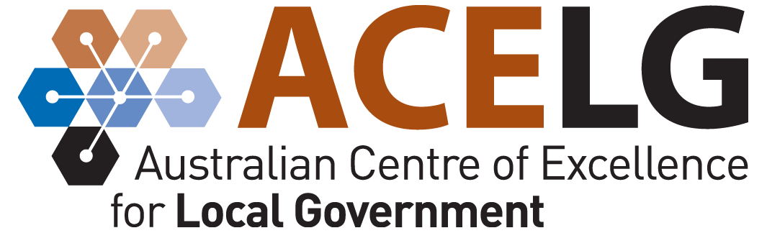

www.acelg.org.au
Ph: 02 9514 3855
E: acelg@acelg.org.au
Insert Council copyright etc. here
Focus area 1: Natural Environment 1
Focus area 2: Local Economy 7
Focus Area 3. Community and Culture 13
Focus Area 4. Rural and Urban Development 19
Focus Area 5. Infrastructure and Services 25
Focus Area 6. Local Governance and Finance 31

Focus area 1: Natural Environment

Long-term goal:
[As per community plan]

Commentary:
[Important background information that provides context for the following account of council’s priorities and intended actions in this focus area]

Strategy:
[As per community plan]

Ongoing Council programs and activities
Program / activity | Current actions | Costs p/a | Responsibility | Indicators of progress

New initiatives
Initiative | Responsibility | Anticipated costs | Timeline | Indicators of progress

Repeat these tables for each strategy listed in the Natural Environment section of the community plan

Other Council programs and activities supporting our natural environment
[This table appears at the end of each focus area to list all programs and activities that do not specifically respond to strategies outlined in the community plan]
Program / activity | Current actions | Costs p/a | Responsibility | Indicators of progress

Resourcing
Projected income for natural environment | Projected expenditure for natural environment

Commentary:

Financial considerations:

Asset management considerations:

Workforce planning considerations:

Reference documents: [Acts and legislation / plans and strategies]

Relevant committees:

Focus area 2: Local Economy

Long-term goal:
[As per community plan]

Commentary:
[Important background information that provides context for the following account of council’s priorities and intended actions in this focus area]

Strategy:
[As per community plan]

Ongoing Council programs and activities
Program / activity | Current actions | Costs p/a | Responsibility | Indicators of progress

New initiatives
Initiative | Responsibility | Anticipated costs | Timeline | Indicators of progress

Repeat these tables for each strategy listed in the Local Economy section of the community plan

Other Council programs and activities supporting our local economy
[This table appears at the end of each focus area to list all programs and activities that do not specifically respond to strategies outlined in the community plan]
Program / activity | Current actions | Costs p/a | Responsibility | Indicators of progress

Resourcing
Projected income for local economy | Projected expenditure for local economy

Commentary:

Financial considerations:

Asset management considerations:

Workforce planning considerations:

Reference documents: [Acts and legislation / plans and strategies]

Relevant committees:

Focus Area 3. Community and Culture

Long-term goal:
[As per community plan]

Commentary:
[Important background information that provides context for the following account of council’s priorities and intended actions in this focus area]

Strategy:
[As per community plan]

Ongoing Council programs and activities
Program / activity | Current actions | Costs p/a | Responsibility | Indicators of progress

New initiatives
Initiative | Responsibility | Anticipated costs | Timeline | Indicators of progress

Repeat these tables for each strategy listed in the Community and Culture section of the community plan

Other Council programs and activities supporting our community and culture
[This table appears at the end of each focus area to list all programs and activities that do not specifically respond to strategies outlined in the community plan]
Program / activity | Current actions | Costs p/a | Responsibility | Indicators of progress

Resourcing
Projected income for community and culture | Projected expenditure for community and culture

Commentary:

Financial considerations:

Asset management considerations:

Workforce planning considerations:

Reference documents: [Acts and legislation / plans and strategies]

Relevant committees:

Focus Area 4. Rural and Urban Development

Long-term goal:
[As per community plan]

Commentary:
[Important background information that provides context for the following account of council’s priorities and intended actions in this focus area]

Strategy:
[As per community plan]

Ongoing Council programs and activities
Program / activity | Current actions | Costs p/a | Responsibility | Indicators of progress

New initiatives
Initiative | Responsibility | Anticipated costs | Timeline | Indicators of progress

Repeat these tables for each strategy listed in the Rural and Urban Development section of the community plan

Other Council programs and activities supporting our rural and urban development
[This table appears at the end of each focus area to list all programs and activities that do not specifically respond to strategies outlined in the community plan]
Program / activity | Current actions | Costs p/a | Responsibility | Indicators of progress

Resourcing
Projected income for rural and urban development | Projected expenditure for rural and urban development

Commentary:

Financial considerations:

Asset management considerations:

Workforce planning considerations:

Reference documents: [Acts and legislation / plans and strategies]

Relevant committees:

Focus Area 5. Infrastructure and Services

Long-term goal:
[As per community plan]

Commentary:
[Important background information that provides context for the following account of council’s priorities and intended actions in this focus area]

Strategy:
[As per community plan]

Ongoing Council programs and activities
Program / activity | Current actions | Costs p/a | Responsibility | Indicators of progress

New initiatives
Initiative | Responsibility | Anticipated costs | Timeline | Indicators of progress

Repeat these tables for each strategy listed in the Infrastructure and Services section of the community plan

Other Council programs and activities supporting our infrastructure and services
[This table appears at the end of each focus area to list all programs and activities that do not specifically respond to strategies outlined in the community plan]
Program / activity | Current actions | Costs p/a | Responsibility | Indicators of progress

Resourcing
Projected income for infrastructure and services | Projected expenditure for infrastructure and services

Commentary:

Financial considerations:

Asset management considerations:

Workforce planning considerations:

Reference documents: [Acts and legislation / plans and strategies]

Relevant committees:

Focus Area 6. Local Governance and Finance

Long-term goal:
[As per community plan]

Commentary:
[Important background information that provides context for the following account of council’s priorities and intended actions in this focus area]

Strategy:
[As per community plan]

Ongoing Council programs and activities
Program / activity | Current actions | Costs p/a | Responsibility | Indicators of progress

New initiatives
Initiative | Responsibility | Anticipated costs | Timeline | Indicators of progress

Repeat these tables for each strategy listed in the Local Governance and Finance section of the community plan

Other Council programs and activities supporting our local governance and finance
[This table appears at the end of each focus area to list all programs and activities that do not specifically respond to strategies outlined in the community plan]
Program / activity | Current actions | Costs p/a | Responsibility | Indicators of progress

Resourcing
Projected income for local governance and finance | Projected expenditure for local governance and finance

Commentary:

Financial considerations:

Asset management considerations:

Workforce planning considerations:

Reference documents: [Acts and legislation / plans and strategies]

Relevant committees:

INSERT COUNCIL LOGO FOR BACK PAGE HERE

