LOCAL GOVERNMENT EXECUTIVE LEADERSHIP PROGRAM QUESTIONNAIRE
Study Population- 76 complete responses were received.
Target Population- The survey was distributed to leading CEOs using a ‘snowball’ method of recommendation. Potential respondents were telephoned and requested to participate.
Headline findings
Future of local government
- 61.9% of participants said they were optimistic about the future of local government over the next 10-20 years while 24% believed the future will be mixed, with some parts of the sector stronger than today, others weaker.
- Participants felt that the most exciting prospects for local government in the next 10-15 years would include;
  - regional local government ties with federal and state government
  - improving delivery of service to the community
  - dealing with climate change
  - managing assets and resources

Issues for senior leaders
- The main issues currently faced by leaders in local governments include;
  - the growing mismatch between resources and responsibilities
  - managing demographic growth/change and social complexity
  - relationships with other levels of government

How prepared do future leaders feel
- 13% of participants replied that they felt ‘fully prepared’ for the challenges that they are likely to face in their job and 64% replied that they felt ‘reasonably prepared’.
- The main areas of professional development currently undertaken by participants included;
  - strategy and leadership
  - people management
  - managing change
- Participants indicated the need for new learning opportunities in strategic leadership and vision, public engagement and governance and ethics.

Innovation
- 76% of participants indicated willingness to showcase innovations in their own council
- Participants replied that the following areas of innovative practice would be of interest to them; Community consultation and engagement; Risk management; Climate change mitigation and adaptation; Asset and infrastructure management; Sustainable economic development.
n = 76

Please tell us about yourself...
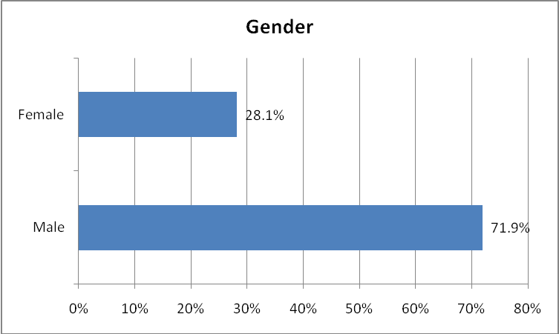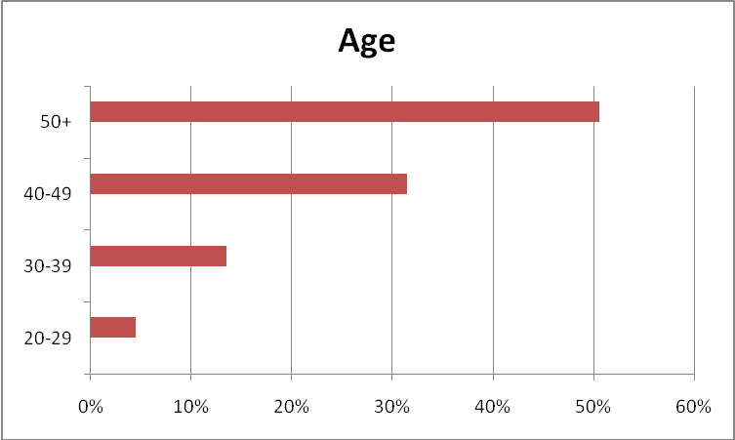
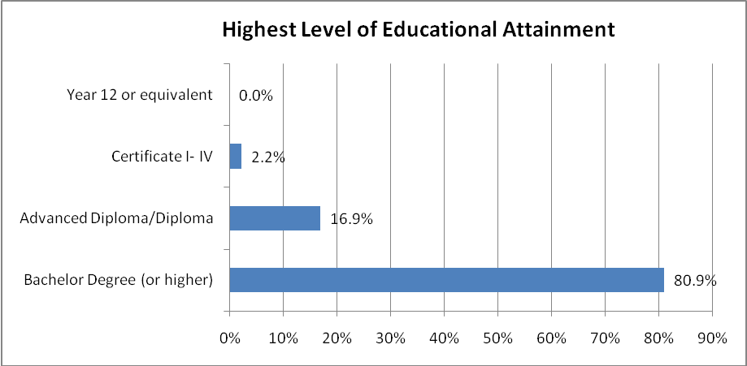
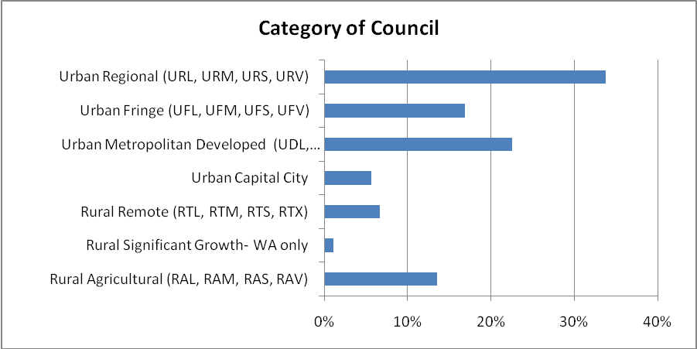

Your thoughts about the present and future of local government...
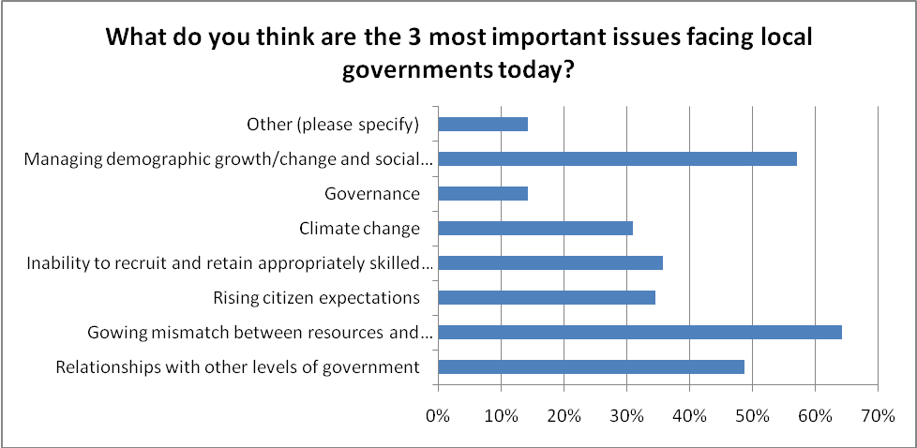
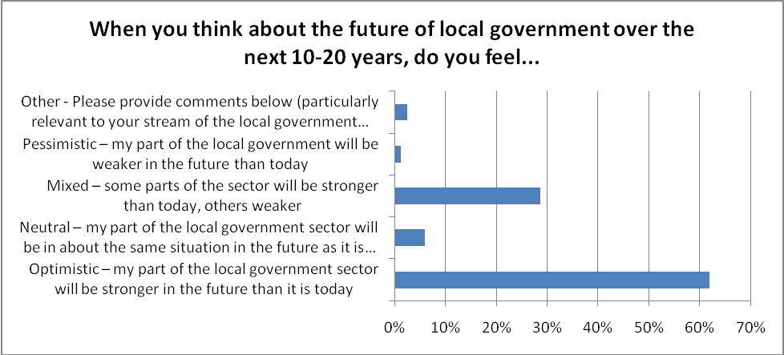

What do you think are the most exciting prospects for local governments over the next 10-15 years?
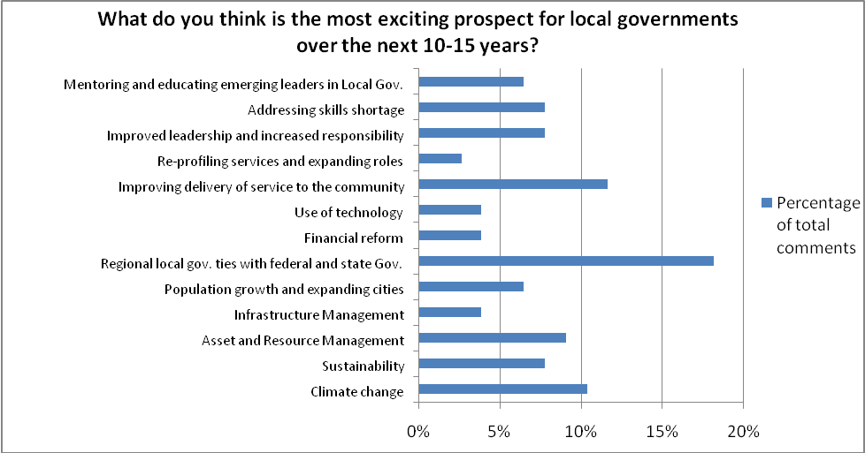

Where you fit in...
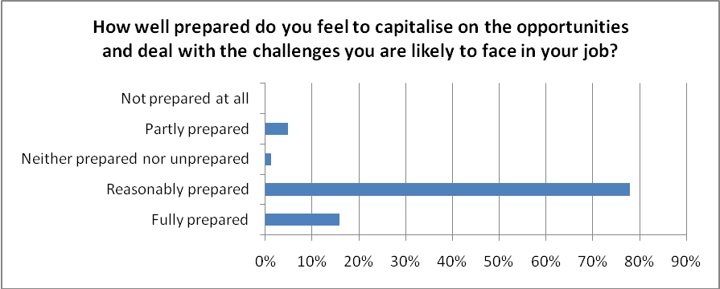

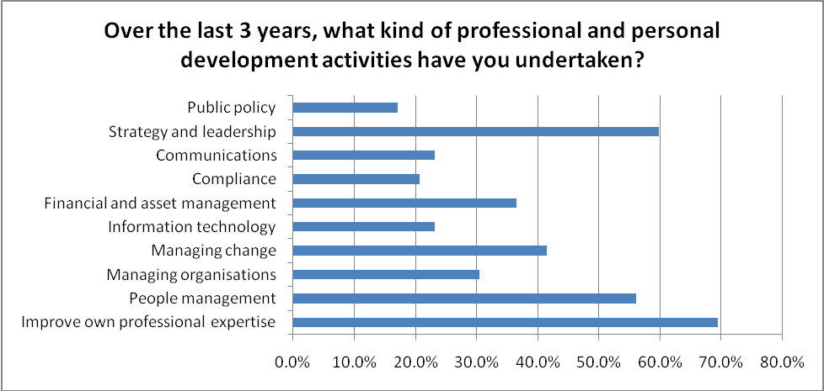
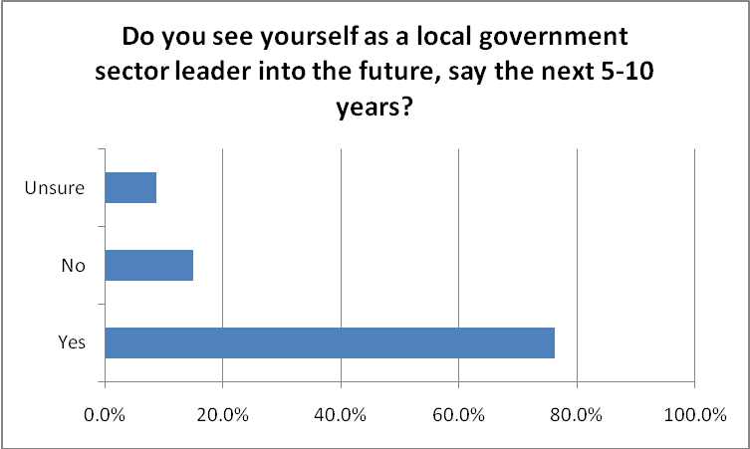

Helping Local Government Leaders Lead
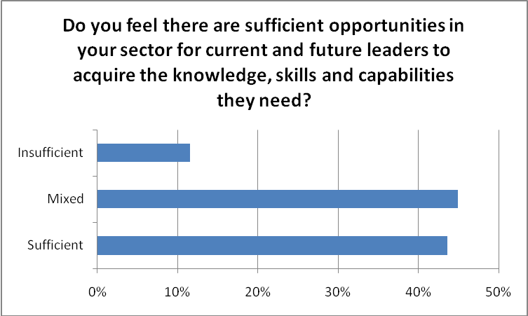

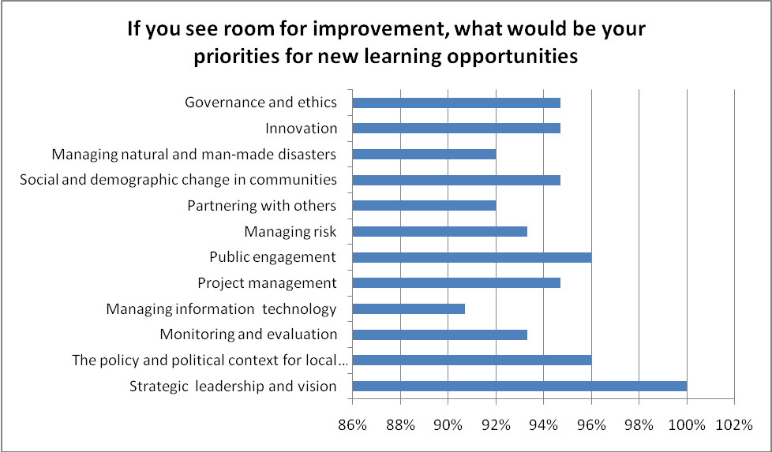

Innovation - New Ideas That Work
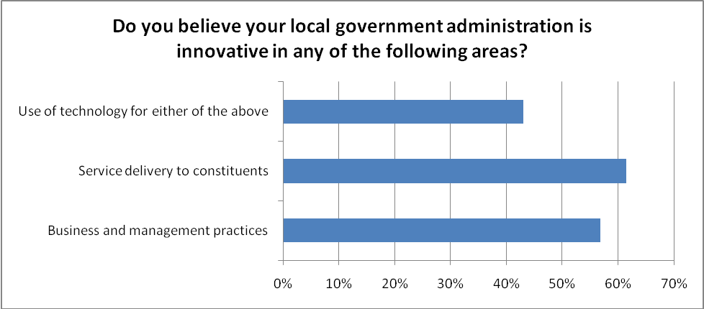
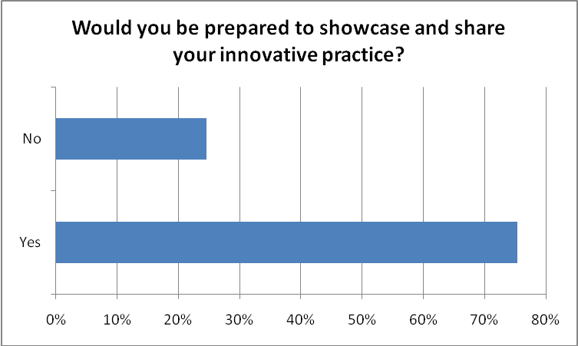

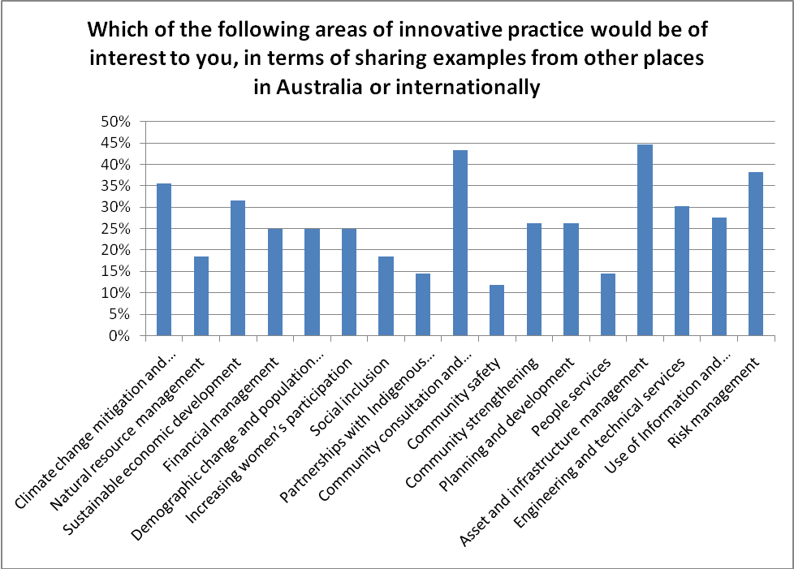

Questionnaire Cross-tabs
