1. Firstly you have install the zoom search engine :- Software Download instructions:  
   ———————————————-  
   Visit this page:  
   <http://www.wrensoft.com/zoom/index.html>  
   and click on the download link
2. After download this software .You have install this software in your Computer
3. After installing this software in your computer . Please copy the license key and paste it into the Zoom Indexer software. Do this by clicking on “Help” in the menu and selecting “Enter license key”. Click “Register” when you have entered your details as shown below screen shot

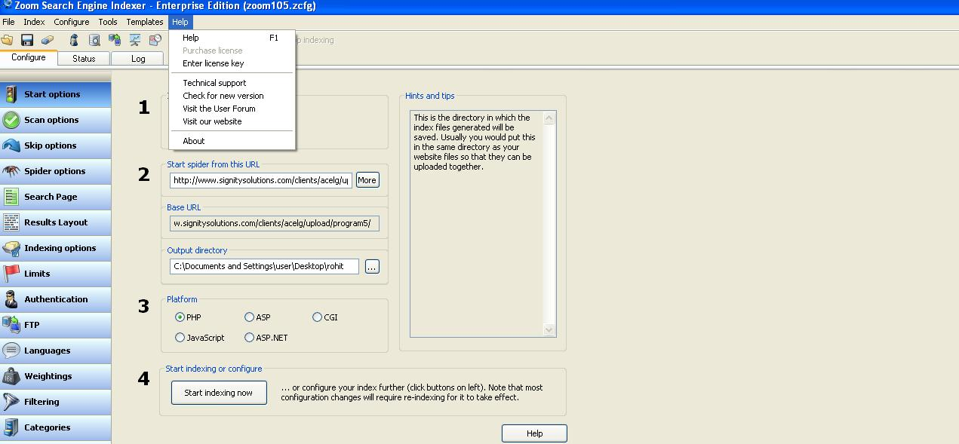

After click on the enter license key another screen is open in which you have enter the license key as you have given as shown below screen

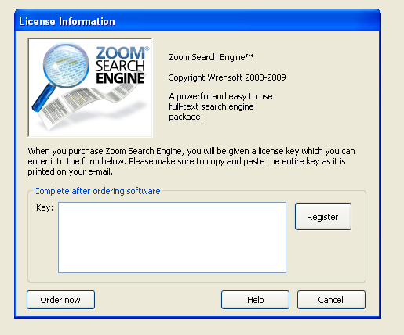

After enter The License

Key . Click on the Register

Button for Registered you License Key

Paste your license key given below

text

STEP 4.After Register the License key.Download the Plugin for this url   
———————————  
<http://www.wrensoft.com/zoom/plugins.html>  
After Download this plugin .you have install this plugin in your computer. Zoom supports the use of plugins to search and index various popular file formats. You need to download these plug-in files if you want to search binary files types like .DOC, .XLS, .PDF, .PPT, etc..

After install this plugin you have add .doc ,.pdf etc file and indexing this file as shown below screen shot

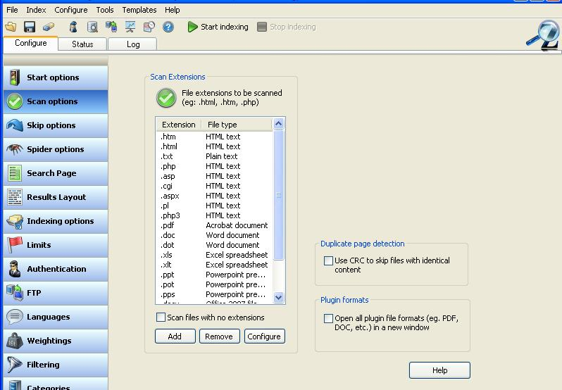

Inset the extension of the files (.doc,.pdf etc) one by one in this text box

Click on the add button for add doc,pdf etc file for indexing

Click on the scan option for add doc .pdf etc file

After click the add button another screen is open as shown below

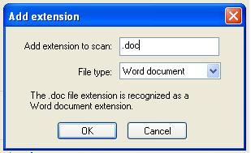

After insert the extension of the file .click on this ok button to add this type of the file in zoom search engine for indexing

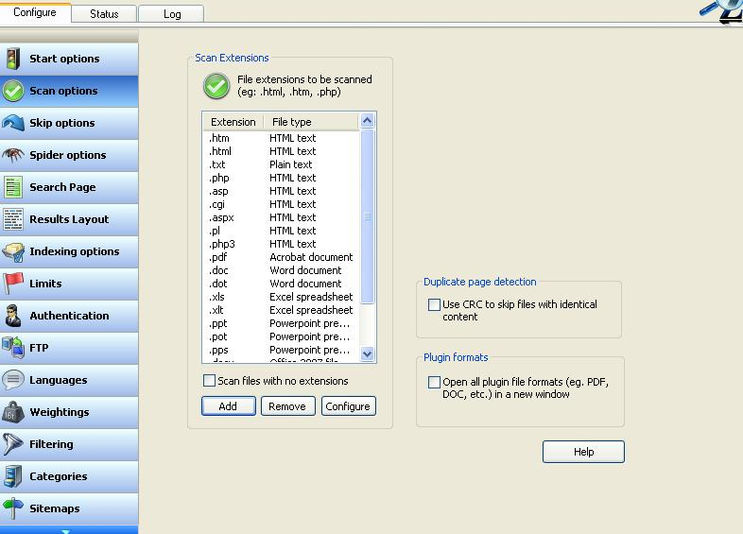

The .doc file as has been show

in this textarea . same process is done for other file extension also

**Step5**. The next step is change the the seach file for zoom search engine with the file search.php as I have given to you with this document. This is the **very necessary** step for this zoom search index.the search file for zoom search engine is open as given below screen shot.

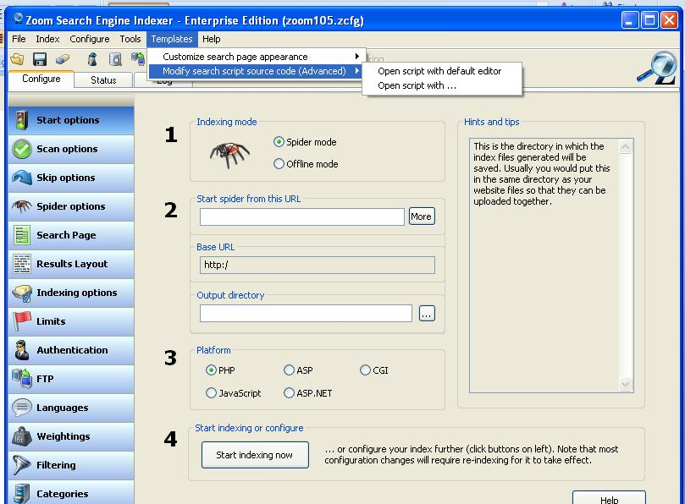

Open the seach file for zoom search engine .click on the open script with icon .after click on this icon seach file for this software is open .Now replace this search file with the file I have given to you with this document and save the file after replace.

**Step 6:-**The next step after replace the search file as shown below screenshot

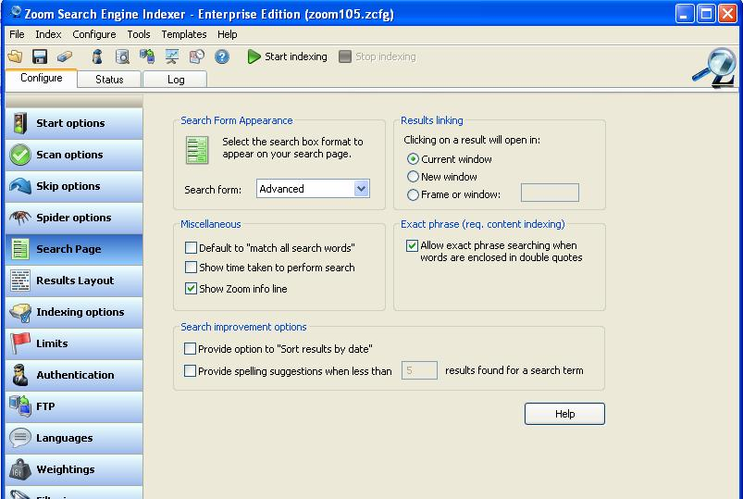

Now unchecked this show zoom info line

Check box.

**Step 7:-**The next step after this one is shown in below screen shot.

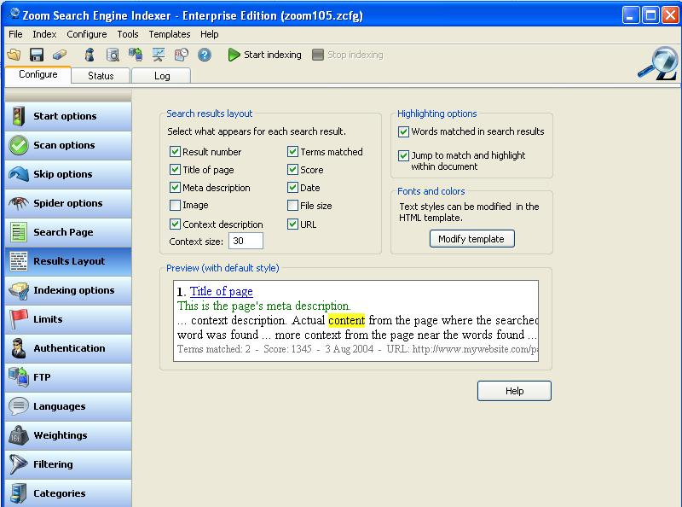

Uncheck the check box of word matched in search results .

**Step 8:-** Now we have start the index of a program1 folder as shown in below screen shot

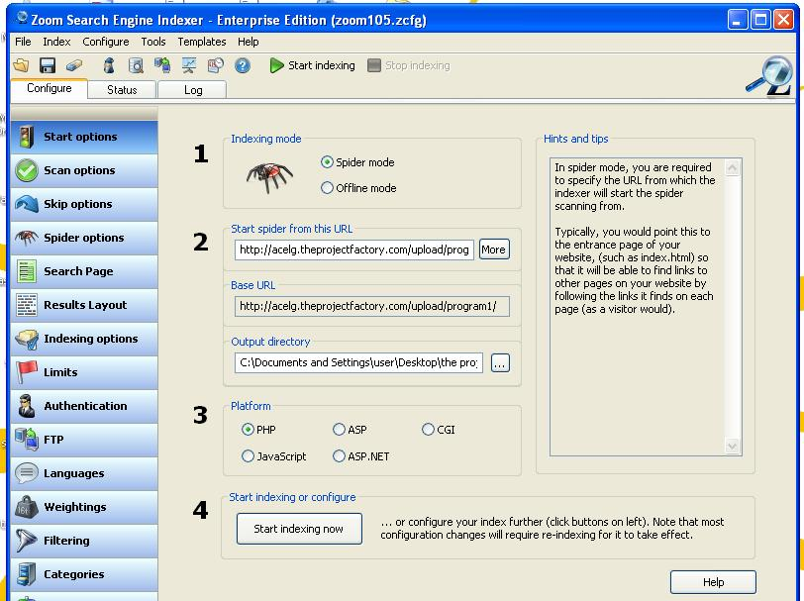

Click on start index button for indexing

Click on this button to browse to the specific folder to which you want to transfer some files.

Insert the URL of the folder which you have start indexing.

Click on the spider mode radio button

Click on start options icon.the screen you have shown is now shown

The above Screen shot we have start indexing of a particular folder of your server as show below url

Start Spider from this URL is : <http://acelg.theprojectfactory.com/upload/program1/>

Next Step is shown in below screen shot:

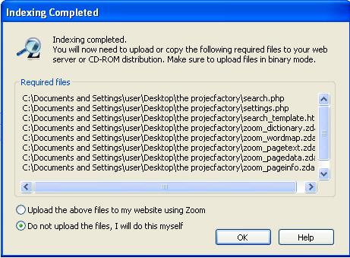

Click on the ok button .

Click on this radio button

After Click on the ok button next window is open in below screen shot.

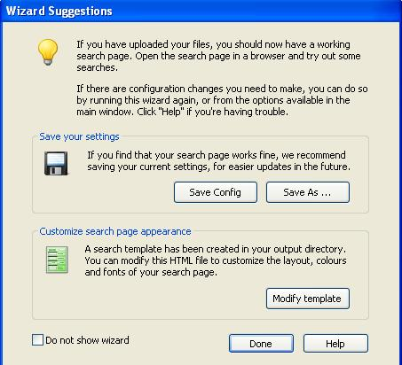

Click on done button

After Click on the done button next window is open as shown in below screen shot

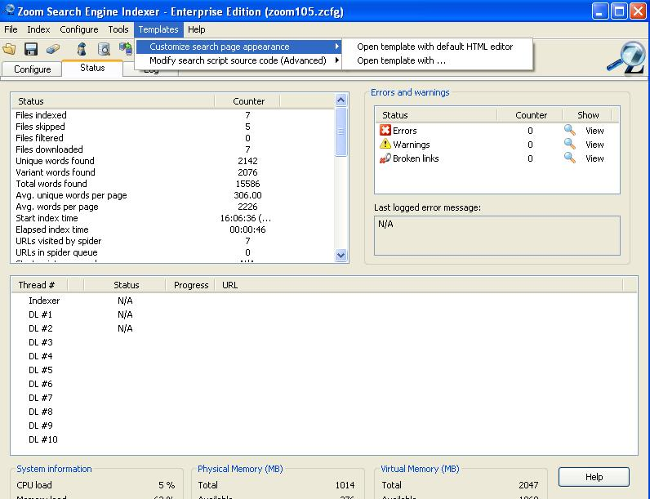

Now click on open template with icon to repalce the template file of zoom index software with file I have given to you with this documents

After replace the template file . save the template file

Next step is given below screen shot

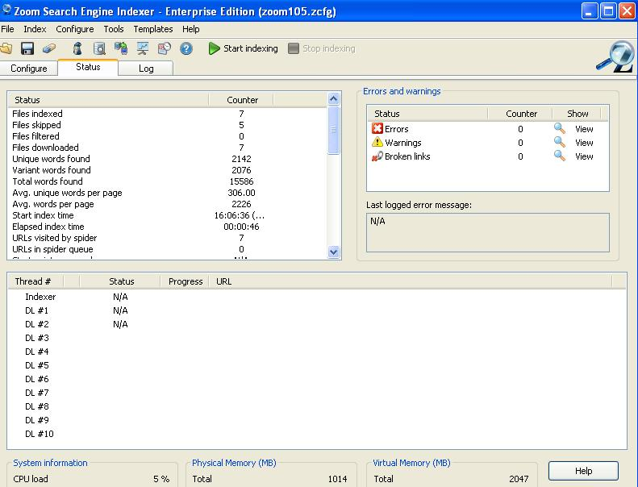

Now click on the Configure icon

After Click on the configure icon next window is open in below screens shot

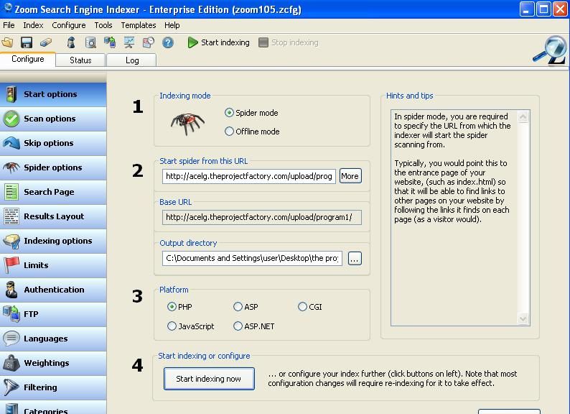

Click on the FTP icon

After the click on the FTP icon.Another window is open as shown in below screenshot

In the below screen shot . firstly you have enter

FTP Server: [ftp.acelg.theprojectfactory.com](ftp://ftp.acelg.theprojectfactory.com)

Next enter the user name and password of the server

After enter the user name and password of the server . now enter the path where the specific files to be upload in a particulare folder in server

The path is given below for program1 folder

acelg.theprojectfactory.com/templates_c/searchprogram1

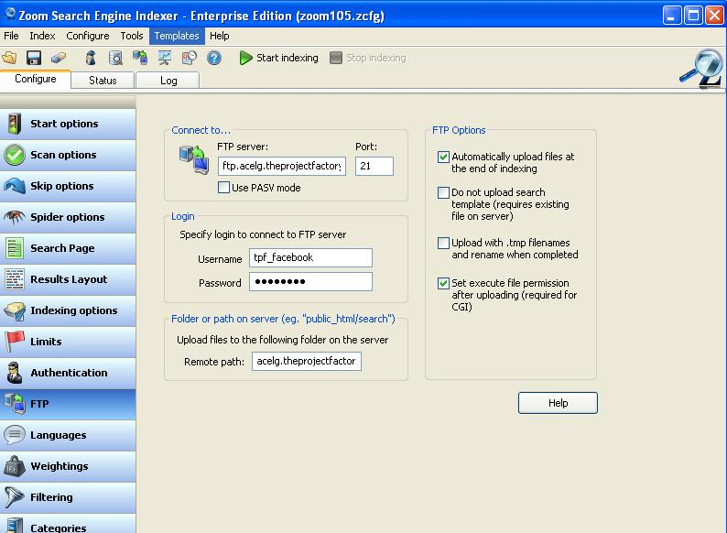

Click on this Check box button also

Click on this Check box button

After the above step Click on the start options icon as shown below screenshot



Now Click on the Start indexing now icon

Click on Start options and the screen you have seen is show

After Click on the Start now indexing icon . Indexing is start know and following screen is open during index of a particular folder as shown below screen shot

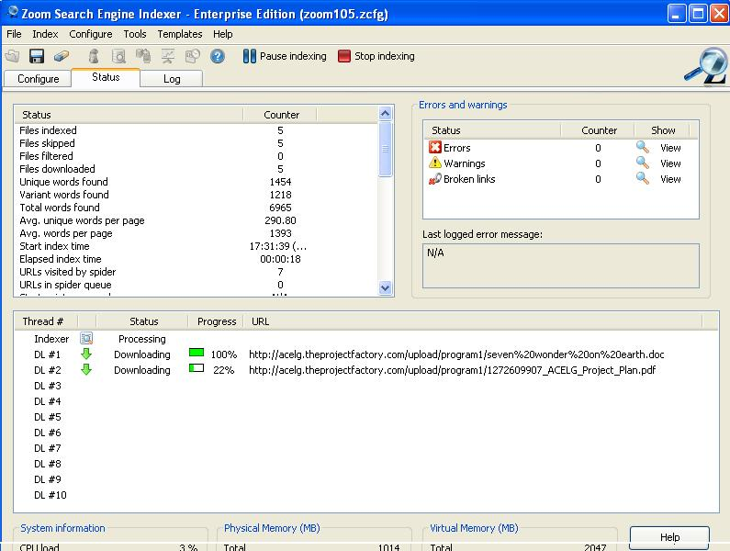

After indexing the folder following screen is shown is given below screenshot

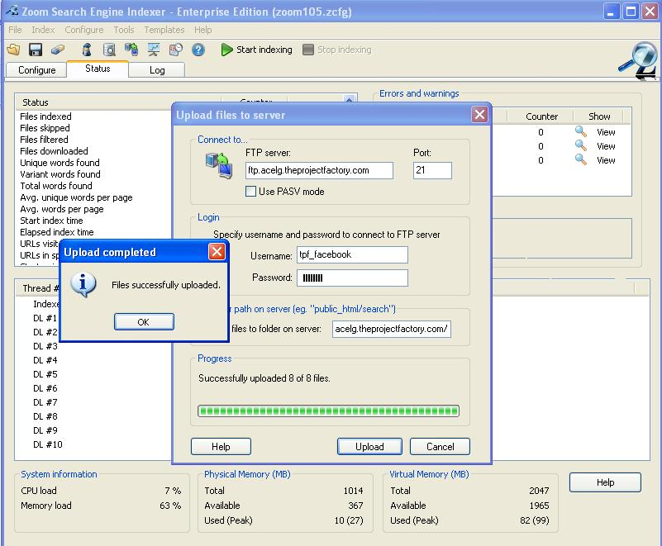

Click on the ok button

After click on the ok button new window is open as shown in below screenshot

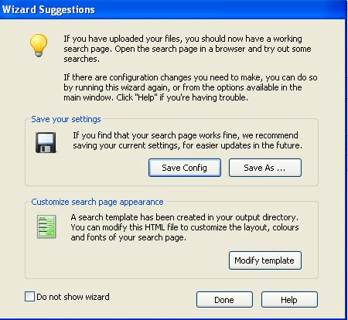

After saving the file in your local

System. Click on the done button

Click on the Save AS button to save the file on your local computer

After click on the done button following screen is show as given below

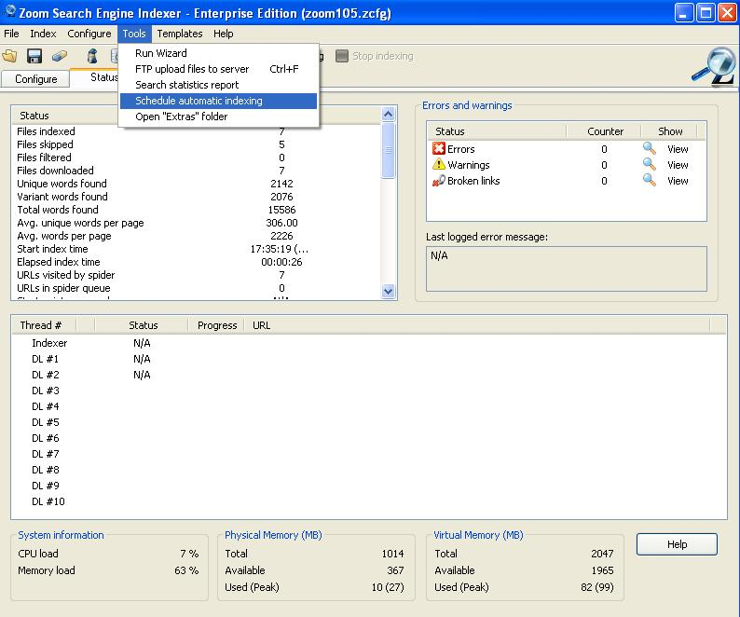

Click on the Tools => Schedule automatic indexing

After click on Schedule automatic indexing the following screen is show as given below screen shot

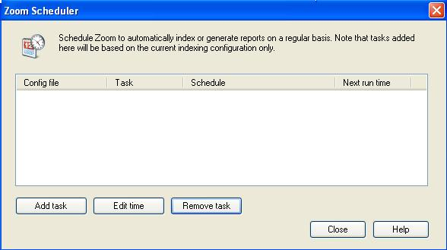

Click on the add task button

After clicking the add task button new window is open as show below screenshot

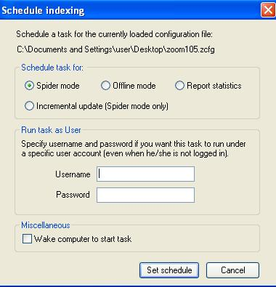

Click on the Set schedule

Button

After click on set schedule button new window is open as shown below screenshots

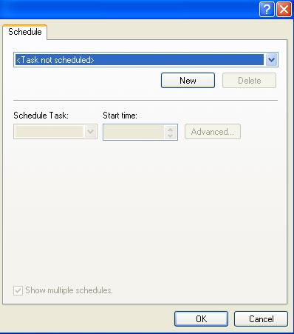

Click on the new button

.After clicking the new button new window is open as shown in below screenshot

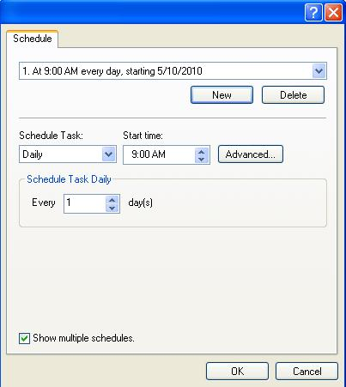

After set the time for autoindexing click on the ok button

Set the time for autoindexing start

Set the task for auto indexing schedule

After click on the ok button new screen is open as shown in below screen shot

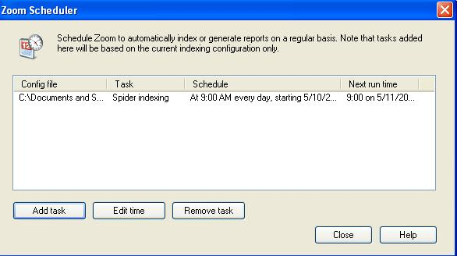

After scheduling is done .we close the widow using this close but ton

We have change the time schedule of autoindexing.click on this edit time button for this purpose

Here we see the time schedule of autoindexing

After Click on close button following screen is show as given below



Change the Remote path

Click on FTP icon and the screen you have see is open

Change the Remote path as given below

Remote Path := acelg.theprojectfactory.com/templates_c/searchprogram2

After change the Remote Path . Click on the Start option icon as shown below screen shot



After change the spider url path.Click on start indexing now button

Click on Start options and the screen you have seen is show

In the above screeshot change the start spider from this Url as given below

Start spider from this Url :=> <http://acelg.theprojectfactory.com/upload/program2/>

After Click on the Start now indexing icon . Indexing is start know and following screen is open during index of a particular folder as shown below screen shot



After indexing the folder following screen is shown is given below screenshot



Click on the ok button

After click on the ok button new window is open as shown in below screenshot



Click on the Save AS button to save the file on your local computer and change the file name .It is necessary

After saving the file in your local System. Click on the done button

System. Click on the done button

After click on the done button following screen is show as given below



Click on the Tools => Schedule automatic indexing

After click on Schedule automatic indexing the following screen is show as given below screen shot



Click on the add task button

After clicking the add task button new window is open as show below screenshot



Click on the Set scheduleButton

After click on set schedule button new window is open as shown below screenshots



Click on the new button

After clicking the new button new window is open as shown in below screenshot

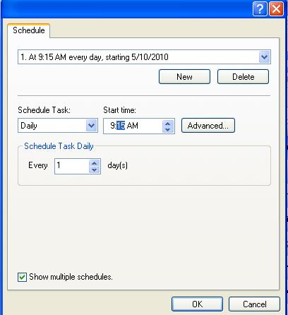

After set the time for autoindexing click on the ok button

Set the time for autoindexing start which is not conflict with the first one

Set the task for auto indexing schedule

After click on the ok button new screen is open as shown in below screen shot

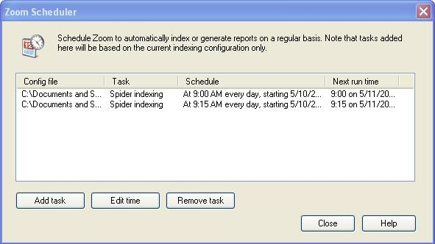

After scheduling is done .we close the widow using this close button

Same procedure and step is done for another folder indexing.