LOCAL GOVERNMENT EXECUTIVE LEADERSHIP PROGRAM QUESTIONNAIRE
n = 76

Please tell us about yourself...
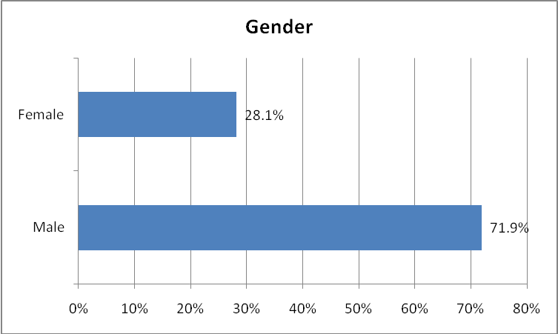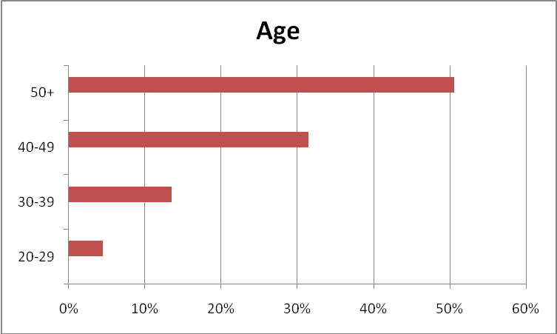
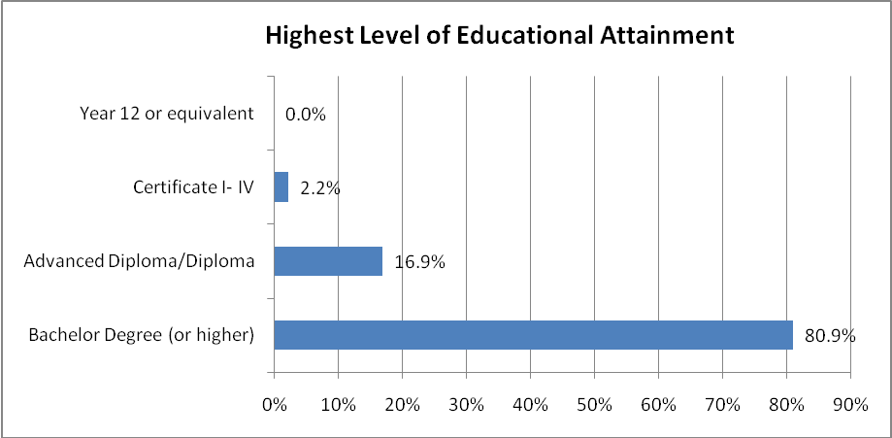

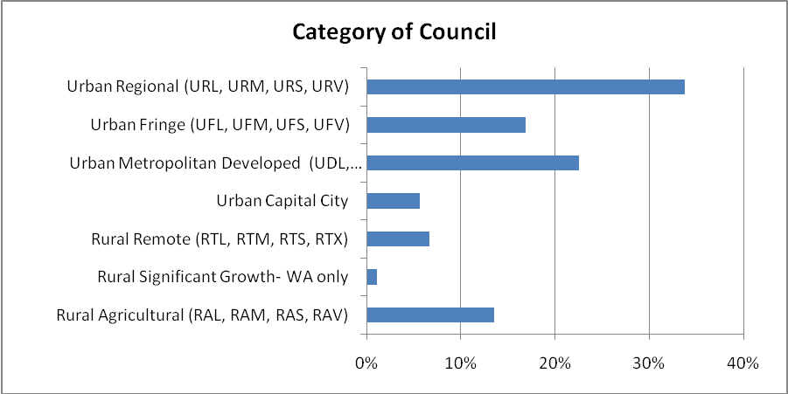

Your thoughts about the present and future of local government...
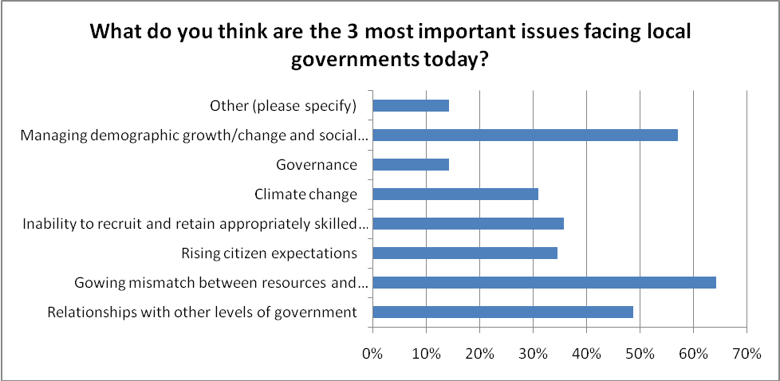
Other Comments
- Infrastructure
- Ensuring Managers are able get on with management and can provide professional advice to Council without fear or favour
- State Government cost shifting
- Competence in changing from government to governance
- Asset Management
- Cooperation with other utilities/sectors appears to be dollar driven not about customers
- Inability to attract high calibre elected representatives

- Old school management deterring younger generation from staying in LG
- Growing need for Asset Management
- The need for Financial Reform in Local Govt in Australia
- Funding

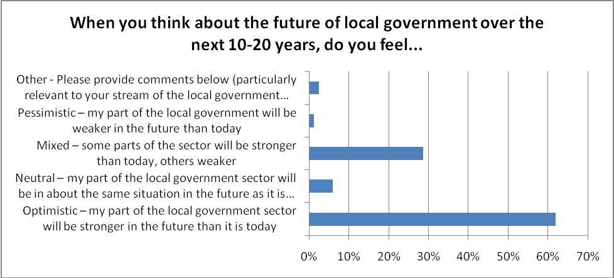
Other Comments
- Some parts moved to commissions / authorities
What do you think are the most exciting prospects for local governments over the next 10-15 years?
- Local scale adaptation to climate change
- Opportunities for innovation, multi-skilling of staff, resource sharing, placing the environment at centre stage in local government public works and better managing community assets in meeting community expectations
- Local government is good at service delivery and problem solving, but only if supported by other spheres of government. Addressing infrastructure and dealing with climate change will be both exciting and traumatic, but will need to be addressed
- Addressing climate change adaptation and mitigation
- Wider influence on the changes that are taking place, climate change, technology awareness by the public and their rights
- Shaping local communities during the challenges that will be imposed by climate change and immigrant-driven population change
- Climate Change
- Social & economic development, associated service requirements coupled with growing population/ demographic changes. Climate change opportunities
- Being involved in key initiatives in relation to climate change, environmental issues and affordable housing
- Ability to actively address climate change at a local level and implement local initiatives

- Constitutional Recognition
- Regional Local Government
- Closer ties with the federal government
- Increased Federal interest and support for the Local Government sector. Taking responsibility for administering climate change initiatives such as private rain water harvesting and solar power schemes

- Growth in collaborative efforts with federal, State, academia, LG associations and IPWEA
- With the inevitable demise of State Government, LG is the obvious leader to deliver services at ground level
- Increased responsibility from state and federal government with latter shedding responsibility
- The strengthening of the relationship between Local and Federal government is providing a new focus on service delivery to the community - and funding is actually being provided for a change!
- Improved consultation with communities; stronger positioning as an employer of choice; direct funding from the Federal Government
- A more direct relationship with federal government. A new look by younger generations into governance and democracy. Always changing, always new ways of doing things
- Growing trend to regionalism
- For WA the changing boundaries of amalgamations
- Strengthening relationships with State & Federal Govt to achieve better community outcomes.
- Having more relationships/partnerships to enhance provision to the community to build stronger services and satisfaction. More collaboration with groups external to government
- Potential devolvement of great power to local government if our system of government changes to become national + local (with removal or radical changes to the current state tier)

- Sustainable development. If acknowledged - the need to change the way things are done
- Developing sustainable communities and advocating for the community
- Environmental sustainability and particularly in regional areas attraction and retention strategies to support social and economic growth
- Sustainable new development- Water sensitive design, green cities, solar & wind power

- Dealing with population growth and the demands placed on the LG sector to provide the structure to accommodate the expectations
- Catering for an expanded Metropolitan City
- New challenges including population growth
- Expanding Development meaning more money in the long term for outer metro regions
- Older generation of male managers will retire in next 10 years
- Dealing with an aging population and a more scarce financial and human resource base
- organizational needs for the future mature generations so that the younger needs are not compromised

- Re-profiling services to match changing household formation and housing forms
- Renewal of community infrastructure
- Delivering innovative new approaches to asset management
- Asset Management of Infrastructure
- Making a significant difference to local communities through service delivery and infrastructure development which keeps pace with their life stage needs and aspirations.
- Service / asset Planning
- Getting Asset management right
- Financial Reform

- Expanded role, additional responsibilities, improved professionalism, larger councils
- Funding Reform
- Providing community leadership in the wider context
- Opportunities to embrace emerging technology and utilise engineering ingenuity and leadership to enhance the standard of living and prosperity of local communities
- The ability to demonstrate leadership in the face of significant change and continuing to deliver relevant and quality services
- More recognition of the important role we play in service delivery

- The continuum of grass roots governance and public accessibility to this level of government
- More mature community engagement approaches
- Ability to take a lead in service delivery that makes a positive difference for communities, an achieving third level
- Growing level of responsibility and hence recognition as a legitimate level of government
- Meeting citizen expectations with limited resources and thinking of smart solutions
- Anticipating and meeting the needs of a changing world with significant uncertainty
- Attract candidates to rural areas
- More impartiality by elected members
- Successfully managing some of the challenges faced because I think there is the capacity to do so
- Australian Centre of Excellence in Local Government
- Opportunities to increase responsibility for new/emerging areas such as health promotion and enhancing community engagement through support of new technology to raise levels of civic participation
- Developing our communities particularly with information technology
- Corporate renewal through starting to truly leverage partnerships, technology and personal mobility - we have lagged the private sector for too long in developing alternative and contemporary service delivery models
- Increase in commercialism, PPP's and innovation in finance/revenue raising
- Career development within local governments
- Local Government will need to take a stronger advocacy role as the other levels of government fail to deliver to local rural communities
- Technological advancements to provide improved service delivery
- Capturing and leveraging the skills, passions and abilities of the Gen Y and Gen Z recruits currently completing their University studies or TAFE courses
- Greater participation of women in senior positions
- To become stronger force in directing government resources
- finding innovative ways to harness the energy, talents, and knowledge of our greatest asset - namely the people in our communities
- There are some significant challenges ahead for local government I look forward to working with my peers in solving them
- Linking Service Levels to Community Plans
- The potential to address skill shortages and promote the sector as a positive and challenging career choice (encourage and increase workforce capacity)
- Within environmental health - moving toward preventative health i.e. - tobacco control, obesity

Where you fit in...
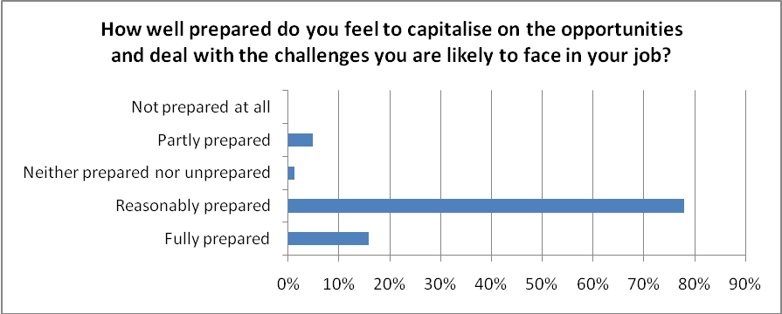
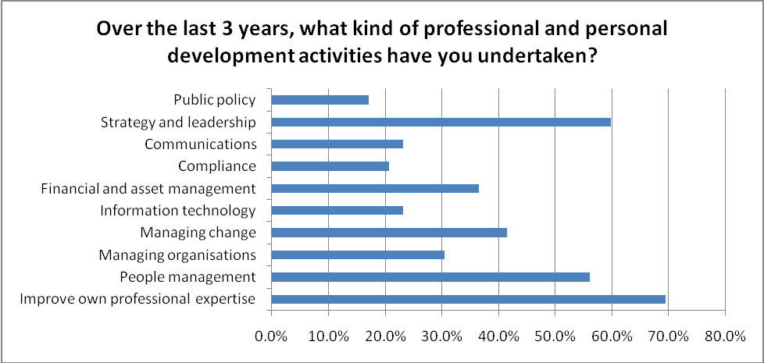

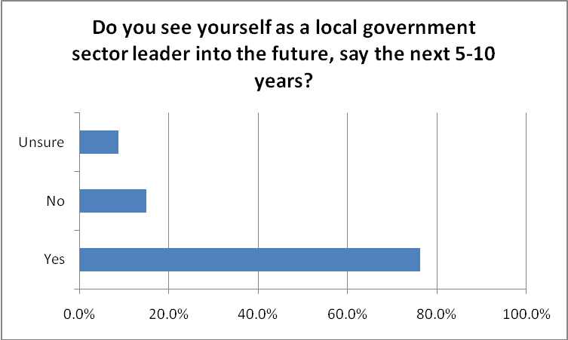
Additional Comments
- LG can make huge differences in actual lives
- I enjoy the ability of providing something for the local community
- As a relatively young CEO with a few years experience and the increasing age of the workforce I believe Local Government will not have a broad experience base to use and I will be well positioned to assist.
- Young, enthusiastic, committed, well grounded experience
- Hopefully still leading a national professional association!
- I believe there is a distinct need for younger leaders to step up and tackle the bigger picture issues currently facing the LG sector
- Have a contract for 5 yrs, beyond that we will see, however really enjoy the sector and having the ability to contribute to the community, organisation and ongoing development of future leaders
- Leading water industry reform in Qld
- It’s a good diverse sector with lots of interesting and fun work
- Involve with professional association to develop further in a leadership role to gain broader knowledge into local government
- Qualifications, track record of achievements at executive level, strategic planning competencies, vision and aspiration.
- I have enthusiasm and confidence in the ability of the sector to deliver, given the right support, leadership and direction
- Yes most definitely, achieving and mentoring succession
- As I like to make a difference to the local Community and being a sector leader seems to be the best way for me to make a difference
- Experience behind me and still young and enthusiastic enough to do it with the respect of my peers
- Working with and for the community is a very rewarding
- Yes. Experience and the ability to communicate across all levels is extremely important
- I communicate well with all levels of personnel and have had a good range of experience in engineering in general

- Able to apply change management to most situations, team building and mentoring to handle the changing environment
- My plan is to gain experience in other areas of engineering, and return to local government with that experience.
- Yes - Barwon Water undertaking a Capital programme that will provide a better service to its customers
- Mature age leaders are essential
- I have been through substantial change over past decade and am well qualified and capable and keen to provide strong and relevant leadership to the sector
- I've just embarked on a new role, my third in local government - it's an exciting sector to work in - close to the community and with great opportunities to learn
- I see the opportunity to grow professionally in an environment that serves my local community.
- I hope to be working at least another 10 years and I love this sector
- Yes, I am committed to this sector and see opportunities for career advancement
- I believe my experience, commitment to local government and positive approach I have something to offer in a leadership role
- I hope to continue in local government. It will depend on the calibre of elected Councillors we attract at the next election
- As long as we continue to progress- if the appetite for change stalls, then I will seek better opportunities to have an influence
- Currently Acting as Director Environment & Engineering and have strong desire to achieve permanent role at this level
- Want to stay in the industry until aged 55, like serving the community and making a difference
- With a decreasing pool of engineers to draw from there is a need for current professionals to guide the next generation
- Already providing leadership in the HR field in the Victorian sector and keen to continue expanding these opportunities
- I have just finished my Masters recently, and look forward to the opportunities that may arise, especially with a restructure under way. I live in the council area and am interested in its future
- I could see myself either becoming a Councillor; or moving into a management position; this path may lead me into returning to academia or going into the private sector for a time, and then returning to the local government sector after gaining that experience. I expect to complete post-graduate studies, most likely a Masters, in this period also
- I believe we need to change the culture associated with local government councillors and the way business was done in order to forward into the future
- Even if I do stand for Council again in 3 years I will be mentoring and supporting other women to do so
- I believe that local environment can be very rewarding
- My involvement with IPWEA will continue and contributions towards LGAQ Roads transport & infrastructure committee
- Motivated, flexible, hard-working, thrives on a challenge, innovative and think outside the square, positive attitude, people person
- We are constantly reviewing our practices and initiatives to ensure that we attract and retain key employees. Our internal processes and risk management approach are amongst the best

Helping Local Government Leaders Lead
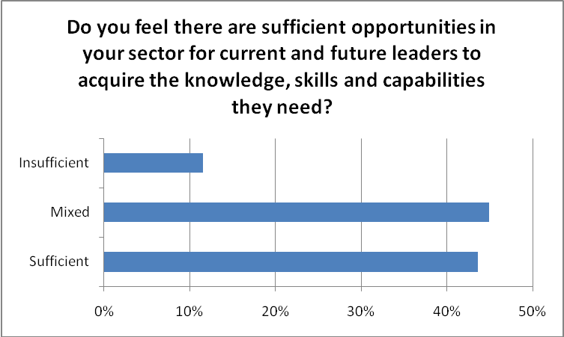

If you answered either ‘mixed’ or ‘insufficient’ to question above, what do you think are the main reasons?
- Most councils operate 20 specialist services; difficult to make transition to organisational level, especially political dimension
- Too localised, not enough quality, relevance or support for whole of sector initiatives
- Need some mentoring for young managers
- Necessary training is remote for rural councils
- Focussing on the right issues for managing future LG organisations
- Often potential leaders are constrained by current systems and procedures and are not able to avail themselves of opportunities to improve their knowledge and skill base. The somewhat "siloed"
- Structure of the LG sector also acts as a constraint as it impedes the development of broad based, multidisciplinary skill sets required to effectively implement change
- Unpredictable future, attitude and motivation of people, mobile work force, and needs are becoming more specialised
- There is a variety of course and training about but most people are time poor and some easy guidance to the better courses and training would be helpful. Also guidance to people on how to develop themselves would be useful. Better mentoring programs would assist this
- Needs to be better opportunities in the organisational structure of local government
- Lack of coordination across the sector, failure for professional associations to adequately survey and then respond and support the requirements of their sector in developing targeted training
- Securing support for appropriate training can be difficult
- LG is not able to recruit the skills needed
- Lack of training institutions focusing on LG leadership

- It’s out there but not always easy to access; need hands on with mentoring not just attend a course
- Mentors are aging and leaving the sector
- The industry is dominated by those who have had little or no experience outside the LG arena, and as such, is limited in the way they see the world
- Staffing and financial resources in smaller LG organisations is prohibitive in allowing the opportunity to undertake training or development programs
- In my area, we consult all the technical works out, and so I only manage consultants a lot of the time
- Unstructured training and mentoring programs, most willing to train and assess do not have the teaching skills. Current and future leaders placing insufficient degree of importance, and thus time into receiving training
- Cost and accessibility
- Professional qualifications & knowledge need reappraised to keep up with changes of the role which is expected to be performed
- Opportunities are there for those who go looking, but there is a real lack of mentoring of the younger generation
- There are lots of opportunities about but few that are specifically targeted toward local government leaders
- Time, opportunity to practice skills obtained, backfill staff, lack of recognition by management of need to develop younger staff
- Clunky, un-coordinated, random, spasmodic at best. Some areas/aspects to training system very good primarily through sector developed and delivered; others non existent or too difficult to access and that's if people know about the opportunities including poor links - processes and communication - between public and private sector operators including the vast array of educational systems and processes where the bulk of government training $ are spent
- Innovative and flexible training delivery options to minimise travel costs
- Need for more targeted development opportunities that go beyond the tangible or transactional roles of leaders to enhance skills in leading people and organisations
- Management courses tend to be narrow-focussed and do not include case studies of local governments in other countries. Training budgets may not be sufficient to support staff in achieving higher qualifications
- Lack of budget for training, lack of time to undertake training, lack of organisational commitment to professional development
- Budgetary decisions (new admin building) leading to significant cuts in funding for training and development
- Partly a lack of relevant programs, but also , in many cases, the conservative (and always busy) approach from many engineering professionals
- Most training is focussed on core skills rather than for the future local govt leader. Succession planning is not done well nor is training for future leadership roles
- Time poor and limited resources to enable the luxury of skilling the next generation of leaders for the sector
- There are still certain barriers in the local government sector for women
- Opportunities for people in rural and remote areas

- Under the old structure I didn't have any opportunities to progress. I undertook a masters to progress myself with minimal support from the workplace. With a new CEO, I feel there will be opportunities to 'shine' and rise further with the knowledge I am currently gaining in my secondment
- Male dominated managerial workforce and councillors
- Opportunities do exist but not all Councillors see the need to improve themselves
- Regional areas will find it hard to obtain the same opportunities that existing in other areas
- Greater promotion of the opportunities is required and for management within organisations to engage/offer this to their staff
- Only if key initiatives are in place and well supported. For example: Succession Planning, a comprehensive Workforce Plan and ongoing professional development
- Focus is too much on management skills, not leadership skills

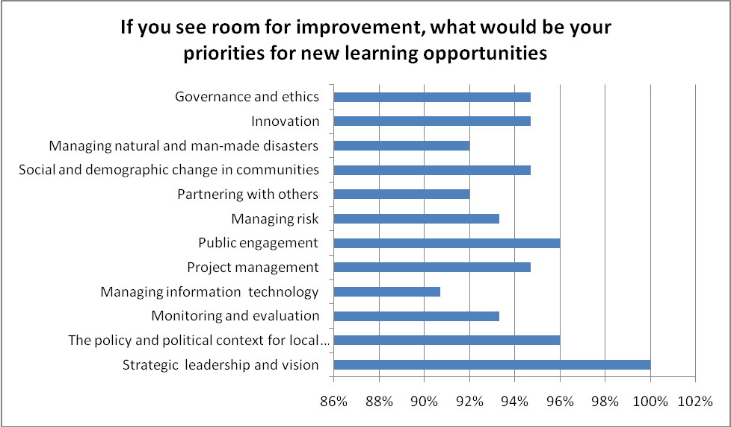

Innovation - New Ideas That Work
